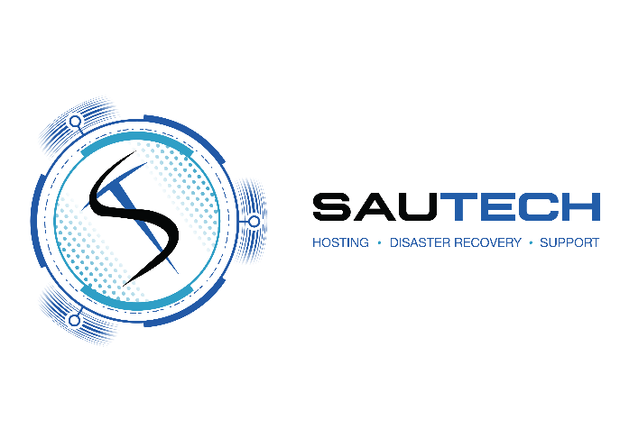

RSA Namibia
34 Stokroos Ave Regus
Breaunanda Maerua Mall, 3rd Floor
1739

Phone: 011 768 1790 Phone: +264 (0) 61 435 8232
Email: sales@sautech.net Email: sales@sautech.com.na
Reg No: 2003/006814/07 Reg No: 2023/0508
Vat No: 4240211963 Vat No: 13757380-015

FIREWALL CHANGE REQUEST FORM:

Requester Information:

Representative Name:________________________________________________________________________

Company / Department:_______________________________________________________________________

Email Address:______________________________________________________________________________

Contact Number:____________________________________________________________________________

Change Type:

☐ New Firewall Rule

☐ Modify Existing Rule

☐ Delete Existing Rule

☐ NAT Configuration

☐ VPN Configuration / Change

☐ Other (specify):___________________________________________________________________________

Business Justification:

Justification:________________________________________________________________________________

__________________________________________________________________________________________

__________________________________________________________________________________________

__________________________________________________________________________________________

Technical Details:

Source IP / Network:_________________________________________________________________________

Destination IP / Network:______________________________________________________________________

Service / Port(s):____________________________________________________________________________

Protocol:___________________________________________________________________________________

Direction:__________________________________________________________________________________

Requested Implementation Date:_______________________________________________________________

Preferred Time:_____________________________________________________________________________

Existing Rule Reference (if applicable): __________________________________________________________

Security Impact Assessment:

☐ Change reviewed for potential security risks

☐ No exposure to sensitive systems

☐ Requires additional security review

Comments:________________________________________________________________________________

Signed at _______________________ on this ________ day of ______________________ 20_____

____________________________ _____________________________
Print Name Designation

____________________________
Signature

